IEEE
THE INSTITUTE OF ELECTRICAL AND ELECTRONICS ENGINEERS, INC.
REGION 6
TRAVEL EXPENSE REIMBURSEMENT POLICY

SUMMARY
General
Overall Purpose: This policy promotes the proper stewardship of IEEE funds by providing general guidelines for the appropriate and legal uses of IEEE funds in support of its mission. Inherent in these responsibilities is the requirement to operate under guidance set forth by the Board of Directors, to follow Generally Accepted Accounting Principles (GAAP), and to comply with all federal stated and local rules and regulations. However, guidelines should not replace judgment, interpretation and analysis of individual situations.
This policy and these procedures apply to every individual who incurs, reviews, or approves travel and business expenses on behalf of IEEE Region 6, regardless of funding source.
Refer to Region 6 Policy on Travel Reimbursement if in doubt.
Reimbursements are for authorized delegates and invitees only.
Region 6 funds are for assistance only - solicit your company's support.

Expense Claims
Always use the current IEEE expense form with major item receipts and vouchers attached. The current form can be found on the IEEE Web site by searching for “20xx Expense Report”.
Claims more than 30 days after travel may be disallowed.
Submit claims to Area Chairmen for Area meeting expenses verification (except for Region 6 Executive Committee members).
Submit claims for Student Activities meeting expenses to the Student Activities Chairman's approval.
Copy all expense forms directly to the Region 6 Treasurer for payment after approval by the appropriate Chair or Director.

Region Meetings
Region 6 Regional Committee travel expenses must be approved, in advance, by Region 6 Director and Treasurer for non-members or unauthorized delegates.
Travel advances for members must receive Region 6 Director approval.

Area Meetings
Attendance is by invitation only.
Region 6 Director’s approval is required for expenses estimated to exceed Area budget.

Student Activity Committee Meetings
Student Activities Chairmen will decide the number of days authorized for meeting (two days maximum).
Authorizations for more than one day must be made in advance.
Air travel is not authorized for student meetings without Region 6 Director’s approval in advance.
Auto mileage reimbursement requires at least three students per vehicle.
Hotel rooms to be reimbursed should be occupied by two students, if appropriate.

Expenses not allowed
Alcoholic beverages except as part of a regular meal and only for the individual expensing the meal.
Entertainment Expenses except where approved by the Region Director.
Stays at a hotel away from the organizer committee hotel where the room-night guarantee impacts the costs for the committee may be disallowed.

IEEE
THE INSTITUTE OF ELECTRICAL AND ELECTRONICS ENGINEERS, INC.
REGION 6
REIMBURSEMENT OF TRAVEL EXPENSES

General Policy
Travel by volunteers is necessary for certain Region 6 activities. At the same time, it is clear that Region 6 resources cannot support all of the travel that is desirable. In order to use the Institute's limited travel resources effectively, these guidelines, based on the IEEE Travel Reimbursement Procedures Manual, apply.
Expenses for travel to any Region 6 meeting are reimbursed only for authorized delegates or invited attendees. It is IEEE policy to provide for, or reimburse, reasonable, authorized travel expenses incurred in connection with the conduct of IEEE business. All persons traveling on IEEE business for whom IEEE pays or reimburses transportation expenses shall travel economically by booking economy class flights well in advance and shopping for low-cost business class train fares and low-cost rental car rates where rental cars are approved by the Director or hi/her designate.
IEEE does not reimburse for the travel expenses of spouses or travel companions as an entitlement. Airfare, additional hotel fees, and incidental costs of spouses or travel companions are never covered but it is recognized that there are occasions where the demand on volunteer time in particular, requires travel with a spouse or companion which may result in some meal costs being expensed. Since the purpose of the business trip is already deemed necessary and the only incremental cost is the spouse/companion meals, expensing the meals is acceptable as long as the cost is reasonable and the practice is not perceived as an entitlement. Spouse/companion costs for purely social gatherings must be reimbursed on the staff or volunteer person’s expense report as a reduction of reimbursed expenses.
The Region budget includes limited funds for expenses related to meetings on Region 6 business. These funds are intended only to assist when it is vital for a member of the Region to attend and they have no other source of compensation for their expenses. The budget could not possibly survive reimbursement of all attendees at the various meetings. Region members are therefore urged to solicit the support of their companies and/or local sections in providing all, or part of, the necessary travel expenses. If everyone adheres to these recommendations, more IEEE members will be able to participate in regional activities.

Expense Claims
Expense claims must be submitted on the current IEEE Expense Report form available on the IEEE Website or on the Region 6 web site, signed by the individual (see Region 6 electronic signature policy for possible uses of that method to sign reports). Whenever vouchers or receipts are normally provided, they must be submitted with the claim. In the event that required receipts cannot be obtained, the "Unsupported Travel Expense" form must be submitted (see Addenda). Also, see “example Expense Report form” at the end of this document.
Turn in the expense form within two weeks after the travel has been completed. Extenuating circumstances, such as your company sharing some of the expenses, are acceptable for turning in the form at a later date. Expenses submitted after 30 days may not be honored.
Submit the form directly to the approving Chair or Director as appropriate and copy the Region 6 Treasurer, except when otherwise directed (see Area meeting and Student Activities Committee meeting). These forms will be audited for acceptance per this policy.
In some cases, the reimbursement will not cover all related expenses. However, by obtaining company support, or by assuming some minor share of the expenses and working together, we can all make it possible for dedicated people to serve the IEEE without a large personal sacrifice.

Specific Policies for Region 6 Meetings
Regional Committee Meeting, is held twice annually in accordance with the bylaws.
The attendee must be a member (or an authorized delegate) of the Region 6 Regional Committee. If not, advance approval for reimbursed attendance must be obtained from the Treasurer, who acts for the Region Director. If deemed necessary by the Regional Director, advance cost authorization may be required of all members. If the total exceeds budget limits, a pro rata percentage reduction of all claims may be made by advance notification to attendees.

Area Meetings
Authorization to attend must be made by invitation or approval of the Area Chairman acting for the Region Director. The Area Chairman will monitor and estimate the costs in advance in cases where airfare is a major consideration in the number of people attending. If these costs exceed budgeted funds, Region 6 Director approval is required. Reimbursements for all Area meetings should use the current IEEE expense forms and should be submitted to the Area Chairman and copy the Region 6 Treasurer for approval and attendance verification. The Area Chairman will forward the approval of the expense forms to the Region 6 Treasurer to complete the reimbursement process.

Student Activities
The Student Activities Chairman will be responsible for deciding the number of overnights authorized for each student at each meeting up to a maximum of two overnight stays. Each person must be notified in advance if they are authorized for more than one overnight stay. Student activities expense reimbursement claims should be e-mailed to the Student Activities Chairman for Region 6 meetings or the Area Chair for area meetings approval and a copy to the Region 6 Treasurer for payment. Traditional mail can be used if preferred. Travel expense is limited to car mileage, and you should have at least three students in the vehicle. Air travel for student meetings shall be authorized by the Region Student Activities Coordinator or the Region 6 Director before the expense is incurred. Hotel rooms should be occupied by two students if possible or appropriate.

Other Meetings
Attendance at other meetings for Region 6 business must have the prior approval of the Region director to receive expense reimbursement.

Reimbursement Policy and Limitations

Airline Costs
Payment is limited to round-trip fare to the meeting location only. Request lowest cost flight fares wherever they apply. Staying over Saturday night may result in less expense to IEEE and is recommended when applicable. Make airline reservations preferably one month or at a minimum two weeks in advance. This action enables you to get the lower-priced seats since typically these low-priced seats fill up early. Use low-fare airlines whenever possible.
Airline Ticket Receipt: If you make reservations via the Web (or your travel agent makes your travel arrangements available via the Web or E-mail), the receipt provided is adequate for Expense Report purposes – or – a copy of the credit card charge receipt if payment is made by that method. Receipt must at minimum identify the departure and arrival cities, date, time and airline flight.
If you share expenses with your employer, please note the amount each entity is paying in the explanation fields at the bottom of your expense report and copy the IEEE amount into the “Plane, Train, Auto Rental” in the appropriate field date, matching when travel occurred.

Hotel and Meal Expense
Stay at the hotel that is recommended by the meeting organizer. This allows IEEE members to meet one another before the official meetings and potentially reduces the costs to the meeting organizer by meeting room-night guarantees; it also allows them to dine together and share IEEE information. If you desire to stay in a more expensive hotel, it is required that you pay the additional costs and only bill IEEE for the equivalent cost of the recommended hotel. Also, if you bring your spouse children or guest, then you should only charge IEEE for the single room rate. Make the appropriate adjustments to your hotel bill prior to sending it to IEEE. Lodging, meal, and local transportation expense will be reimbursed at actual cost. Wherever possible, receipts should be obtained and attached to expense claims when submitted for payment. It is contemplated that reasonable judgment will be exercised in making these expenditures.

Car Rental
Car rental is not an allowable expense without prior approval by the Region Director. The exception to this rule is when cheaper transportation is not available or you can demonstrate cost savings to IEEE by using a rental car. Attach a statement to your expense report giving the reason for using a rental car and detailing the cost savings to IEEE.
Examples of this savings may include sharing of a rental car for local travel from/to a meeting site, allowing for ease of local travel if multiple meetings sites are to be visited in the same town, arrival at a time where local transportation options are minimal or unavailable (airline flight arrival between midnight and 6 AM for example) or where access to local meeting services is required and no other transportation option is convenient.
IEEE Business Automobile Liability Insurance (Collision/Comprehensive Liability) is primary on rented automobiles, and coverage purchased through the rental company is not necessary and will not be reimbursed.
When evaluating use of a rental vs. private car, the distance travelled will often determine the lowest cost alternative. Use of a private car will be reimbursed up to the amount for the quoted rental car plus an estimated cost for fuel or mileage, or at the IRS approved personal mileage rate for business travel, whichever is less.
If air transport is the normal travel mode, but you wish to drive to take your companion along, the reimbursement will be limited to the cost of one lowest cost flight fare or as determined above for rental car vs. private vehicle, whichever is less. Auxiliary fees (checked bags, seat reservation, on-line or web ticketing fees, etc.) are not considered when determining reimbursement amounts.
Only one person in a private vehicle may make a claim for reimbursement. Travel over 50 miles one-way will be reimbursed at the IRS approved mileage rate for business travel up to a maximum which is the equivalent of Coach Air Fare between points, or points of equivalent distance if no air service exists.

Day Limit
Regional Committee Meeting and Area Meeting attendees will be authorized expenses for only the number of days of the meeting. If an extended stay is deemed appropriate, it shall be approved by the Region Director in advance (See Airline Costs for details of use of this policy). Members living within a 50-mile radius of a meeting location will not normally be authorized any reimbursement for meals or hotel.

General Comments
Please share expenses with your company or employer if possible. This shows your company your active involvement with IEEE and gives you additional recognition. Plan ahead. Try to combine your IEEE business with a trip you are making to save time and dollars.

Policy Exceptions and Revisions
The Regional Executive Committee authorizes the Region Director, with the advice and consent of the Region Budget Committee, to alter this policy if, in their judgment, it is reasonable to predict the expenditures will exceed the Region budget. In special hardship cases, or where special circumstances warrant, these general policy statements may be waived by PRIOR approval of the additional expense reimbursement from the Region Director.
Submit hotel, meal, and local transportation receipts with current IEEE expense form. All expenses exceeding $25 must have a receipt attached to the expense report to be approved.

IEEE
THE INSTITUTE OF ELECTRICAL AND ELECTRONICS ENGINEERS, INC.
REGION 6
SPECIFIC POLICIES FOR STUDENT TRAVEL TO REGION 6 MEETINGS

Student Activities
Students should take advantage of any assistance available from local Sections to help fund travel to Section and Area meetings.

Fall Area Training Meetings
Students living within a 50-mile radius of the Area meeting location do not normally receive any travel or meal reimbursements.
Mileage will be reimbursed for one car/van from each student branch.
If distance traveled is more than 200 miles, one night's lodging and one day's meals will be reimbursed if necessary. Hotel rooms should be shared by two or more students where appropriate.
Student branch faculty advisors should travel with the students wherever possible and appropriate. Separate travel requests must have prior approval of the Area Chairman.
Where travel by air is absolutely necessary, prior approval of the Area Chairman and Region 6 Director or his designate is required. Air travel, if approved, is limited to one student leader and one faculty advisor from each branch. Meals and lodging for one day will be reimbursed if required. Travel from Alaska and Hawaii must be approved by the Region 6 Director prior to the meeting.

Spring Area Meetings and Contests
Students living within a 50-mile radius of the Area meeting location do not normally receive any travel or meal reimbursements.
Mileage will be reimbursed for two cars/vans from each branch if there are two or more contestants in multiple Area Contests.
If distance traveled is more than 200 miles, one night's lodging and one day's meals will be reimbursed if necessary. Hotel rooms should be shared by two or more students where appropriate.
Student branch faculty advisors should travel with the students wherever possible and appropriate. Separate travel requests must have prior approval of the Area Chairman.
Where travel by air is absolutely necessary, prior approval of the Area Chairman and Region Director or their designate is required. Air travel is limited to one student leader, the faculty advisor, and one contestant for each contest being held. Meals and lodging for one day will be reimbursed as necessary. Any travel from Alaska or Hawaii must be approved by the Region Director prior to the meeting.

Student Paper Contest
Contestants living within a 50-mile radius of contest do not normally receive any travel reimbursements.
Mileage for each of the five Area contest winners will be reimbursed from their residences to contest, and lodging and meals for up to two days may be claimed as necessary.
Requests for travel by the Advisors of the five contestants must be made to the Region 6 Student Activities Chairman prior to the meeting.
Where air travel is necessary, reimbursement is limited to the lowest available air fares and up to two days' lodging and meals.

Reimbursement Claims
All claims for travel (students and faculty advisors) should be submitted on the current IEEE Expense Report form and e-mailed to the Area Chair with a copy to the Region 6 Student Activities Chairman and a copy to the Region 6 Treasurer. Traditional mail can be used if preferred. Once approved by the Area Chair, the Region 6 Treasurer will issue payment.
All expenses exceeding $25 must have a receipt attached to the expense report to be approved.

IEEE
THE INSTITUTE OF ELECTRICAL AND ELECTRONICS ENGINEERS, INC.
REGION 6
SPECIFIC POLICIES FOR ELECTRONIC SIGANTURES

SUMMARY
General
IEEE’s member policies need to reflect and use what has been developed by our members and profession. Electronic Signatures have been developed by the profession and the IEEE believes it is matured to the point where we can use this technology advancement for our member’s interaction with the Region. An electronic signature, or e-signature, is any electronic means that indicates either that a person adopts the contents of an electronic message, or more broadly that the person who claims to have written a message is the one who wrote it (and that the message received is the one that was sent). In the United States, the definition of what qualifies as an electronic signature is set out in the Uniform Electronic Transactions Act ("UETA") released by the National Conference of Commissioners on Uniform State Laws (NCCUSL).
A secure electronic signature is as an electronic signature that:
- Is unique to the person making the signature;
- The technology or process used to make the signature is under the sole control of the person making the signature;
- The technology or process can be used to identify the person using the technology or process; and
- The electronic signature can be linked with an electronic document in such a way that it can be used to determine whether the electronic document has been changed since the electronic signature was incorporated in, attached to or associated with the electronic document.

Benefits of Electronic Signatures
Electronic forms or scanned document files can be digitally signed. This eliminates the need to print, sign and rescan forms that require signatures.
Security of the file is guaranteed as any alteration will either not be possible or be such that it is obvious that a change was made.
In conjunction with encoding or otherwise preventing unauthorized people from opening a file, electronic signatures confirm that no changes were made to any file and may improve security of sending sensitive data via e-mail.

Electronic Signatures Policy
Members who require submitting forms to Region 6 where a signature is required can optionally use an Electronic Signature technology.
Any software package that meets the requirements for the UETA is acceptable.
It is acceptable to use mobile devices to generate electronic signatures if the form for submission can be placed on that device.
No policy concerning signatures will negate the ability to submit a form using traditional signatures by a member or other authorized person.
Refer to the current Region Treasurer concerning questions on acceptable software packages for use in generating electronic signatures and is submitting documents utilizing electronic signatures.

Electronic Signatures Examples

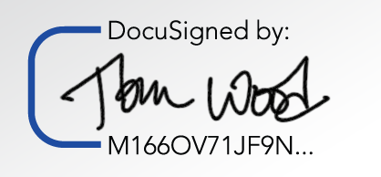
Figure 1 - Example from DocuSign for eSignature

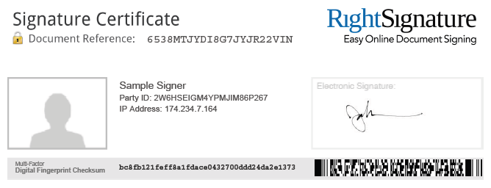
Figure 2 - Example from RightSignature

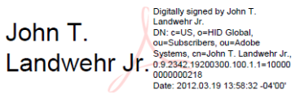
Figure 3 - Example from PDF-Xchange

Figure 4 - Example from VeriSign

Note that in all cases a unique digital fingerprint is created which is used. This is to confirm that the file has not been changed (or at minimum, a change can be determined to have occurred).

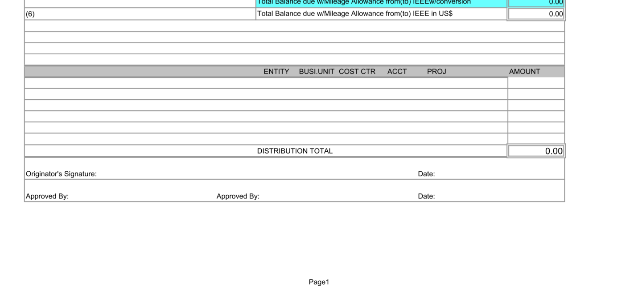
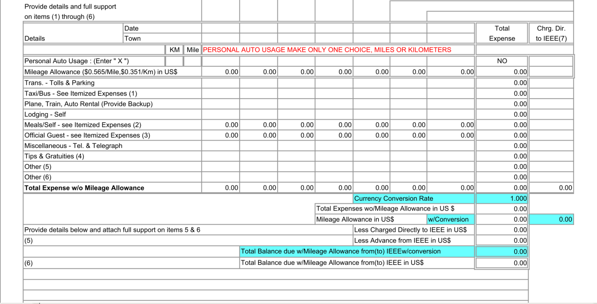
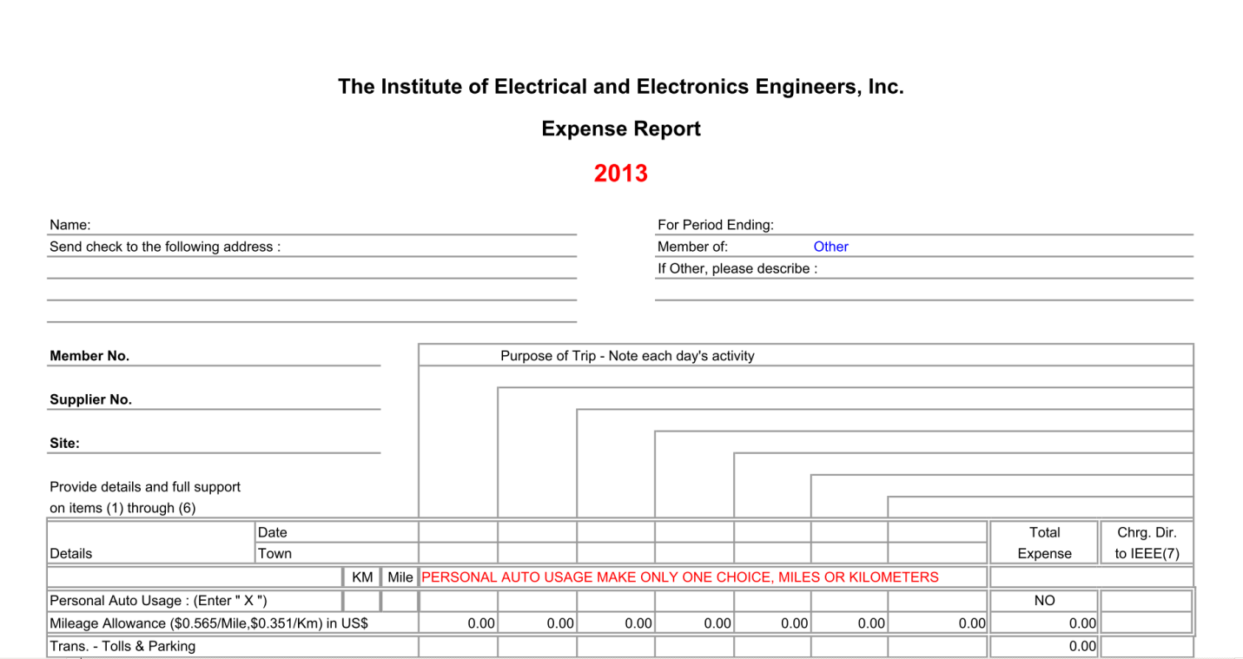
If there any special expenses (reproduction and meeting expenses, etc.) include them above in “Other” and list a brief explanation here
These fields are populated by entries on page 2 and 3 where detailed accountings of each day’s meals are input.
Place an “X” in the miles cell so calculations based on mileage is correct – enter total miles for each day, amount is calculated in the cell below
Be sure to sign and date the report – see Electronic Signatures Policy for use of that signing method
Click on this cell to see options; if there is no correct selection use other and put description in the next line (such as, Section xxx representative, yyy Region 6 committee, etc.)
Address where the check is to be sent – include zip+4 if known (look on your Spectrum mailing sticker for this)
Include member number
Describe main purpose of trip each day, en-route to xxx meeting, attending xxx meeting, return from xxx meeting, etc.

IEEE
THE INSTITUTE OF ELECTRICAL AND ELECTRONICS ENGINEERS, INC.
REGION 6

MEMORANDUM
TO: IEEE Region 6 Director
FROM:
DATE:
SUBJECT: Unsupported Travel Expenses
This is to certify that expenses as outlined below were incurred by me in the course of carrying out IEEE activities. The receipts, as required by IEEE Policy Statement 10.6, could not be obtained because of circumstances in the manner of payment.
Date Amount Type of Expenditure Circumstances

_______________________________________
Signed

