About the 2017 Global Humanitarian Technology
Solutions Challenge

Ensuring sustainable food consumption and production

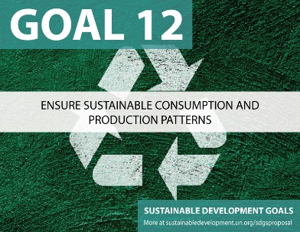
The United Nations Development Program identified seventeen (17) Sustainable Development Goals (SDGs) as a global call for action to end poverty, protect the planet and ensure that all people enjoy peace and prosperity.

The 2017 Global Humanitarian Technology Solutions Challenge was developed to focus on Goal 12.3.
Goal 12: End hunger, achieve food security and improved nutrition and promote sustainable agriculture
Section 3: Decrease by half the per capita global food waste at the retail and consumer levels and reduce food losses along production and supply chains, including post-harvest losses.

The solution can address any element or issue that relates to Section 3. That includes, but is not limited to, the food supply and production chain including crop production, processing, post-harvest losses, retail distribution, consumer use and lost product.

The project solution can be developed by individuals or by a Solutions Challenge Team. To be eligible to enter the GHTC Solutions Challenge, at least one team members must be an IEEE member in good standing at the time that the entry is submitted.

Key dates:
- Submit a Project Statement of Intent not later than July 15th, 2017. The Statement of Intent can be submitted as a video (2-minute maximum) or written statement (250-word maximum). The Statement of Intent provides a basic description of the project and project scope. The Statement of Intent must also provide the names, university affiliation (as applicable) and academic discipline of each team member.
- Solution Submission is due not later than September 12th, 2017. The submission may be a video (10-minute maximum) or written paper (5,000-word maximum). The project can be a working prototype, scale model, detailed engineering specifications, an in-installation process or a fully operational project. The description must provide the description, impact (anticipated or real), costs, installation (real or concept).

Solutions Challenge Teams will be judged on the creativity and applicability of their design, completeness of their documentation, and quality of their presentation. The winning team will be notified not later than October 1st, 2017. The decision of the judges is final.

For additional information contact GHTCsolutions@ieee.org

