How to Post to the Region 6 WordPress Site

Open your browser and navigate to: http://sites.ieee.org/r6/wp-admin

Login using your Region 6 WordPress user and password. You should have received an email inviting you to create an account. If you need an account, contact Dave Butcher (dbutcher@ieee.org).

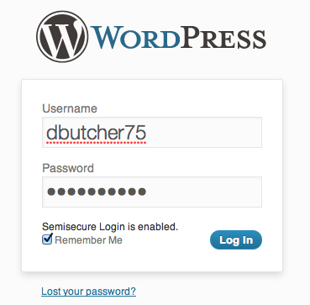

Once you have successfully authenticated with WordPress, you will be presented with the dashboard. On the left menu select “Posts.”

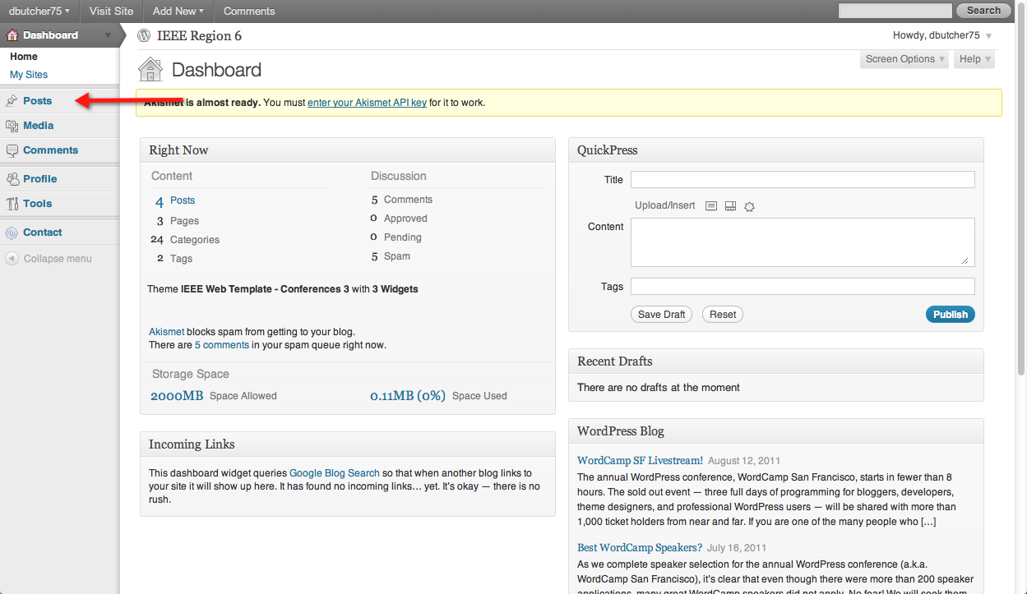

You will be presented with a list of all of your posts (if you have previously created posts). You can edit the previous posts here. To create a new post, click on the “Add New” button.

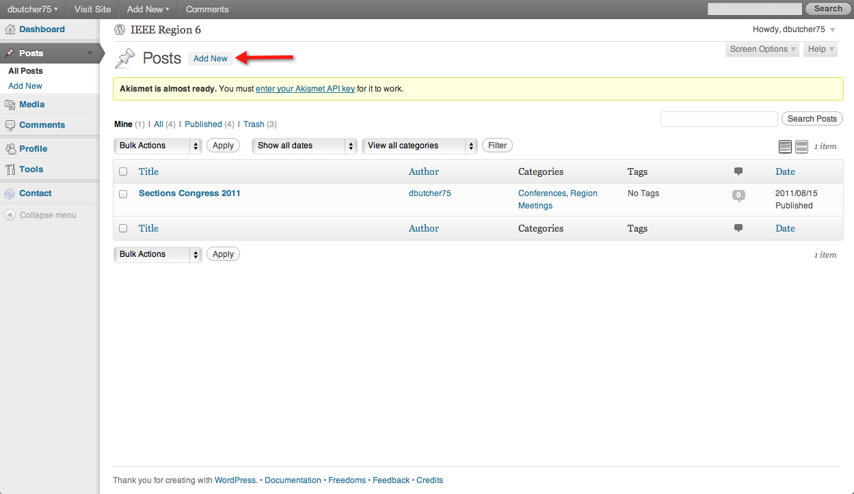
Create your post:

- First you need a title. Type the title into the top text box.
- Next type your post into the text area. Use the formatting buttons above the text area to format your text. Note: cutting and pasting formatted text (e.g. cut from Word) usually results in a mess. Cut plain text and then use the WordPress formatting buttons.
- Choose one or more categories for your post. In my example, I have an article on the student paper contest. For my post, I checked the category, Students. Categories map to Region 6 activities, therefore it is likely that the category for your post will be your role within the region (e.g. Student Activities Chair = Students, PACE Chair = PACE). A list of categories is at the end of this document. If you feel we are missing a category, please contact Dave Butcher (dbutcher@ieee.org).
- When everything looks good, hit the “Publish” button. If you find a mistake later, you can still edit your post from the “Posts” menu.
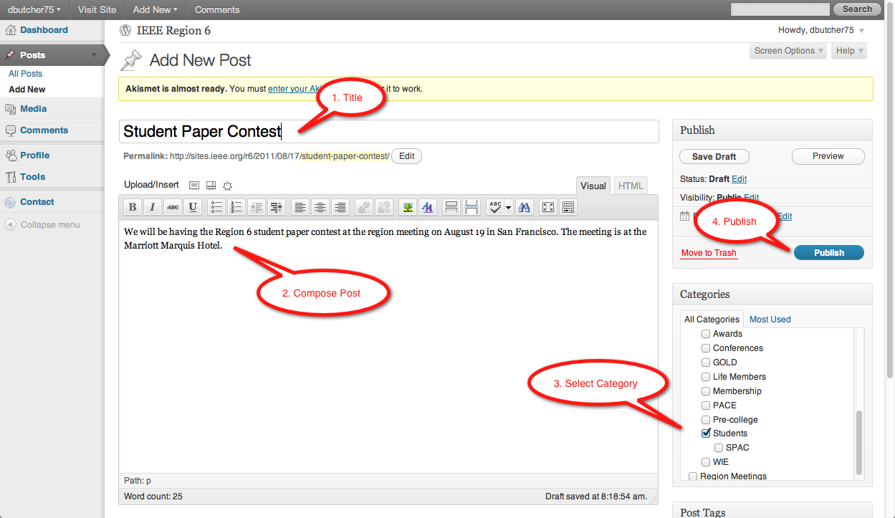

It is that simple to create posts in WordPress. If you would like to view your post after publishing, hit the “View Post” link at the top of the page after publishing.

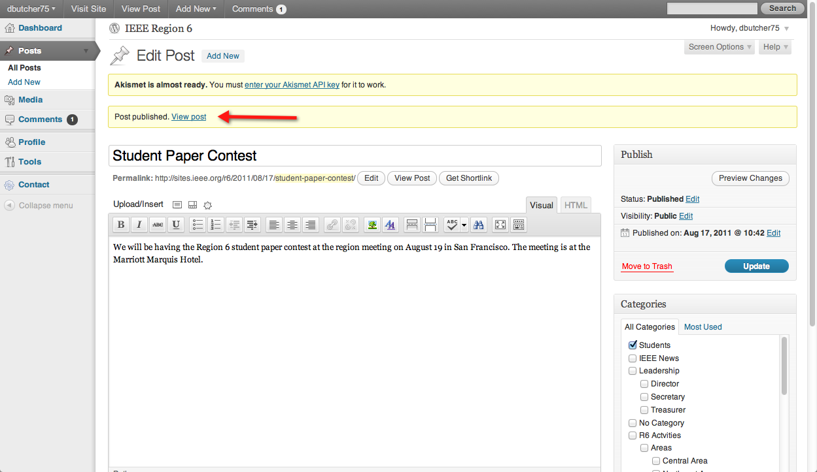

And here is my post:

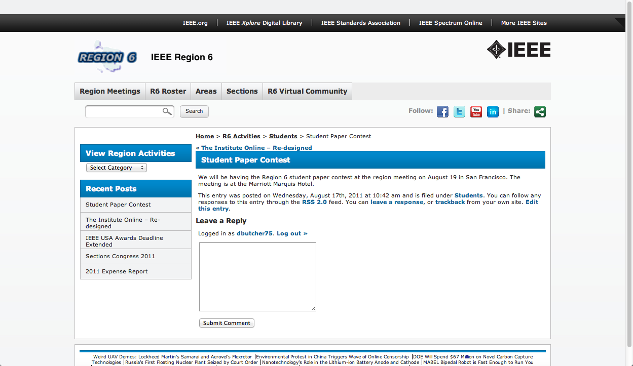

Appendix: Region 6 Categories

IEEE News – General IEEE News
Leadership – Grouping for R6 Officers
Director – Director posts
Secretary – Secretary posts
Treasurer – Treasurer posts
R6 Activities – Grouping for all Region 6 activity chairs
Areas – Grouping for area chairs
Central Area – News for the R6 Central Area
Northeast Area – News for the R6 Northeast Area
Northwest Area – News for the R6 Northwest Area
Southern Area – News for the R6 Southern Area
Southwest Area – News for the R6 Southwest Area
Awards – News about awards
Conferences – News about R6 conferences
GOLD – News about GOLD
Life Members – News for Life Members
Membership – News from the MD chair
PACE – News from the PACE chair
Pre-college – News about pre-college education

